Grenodo Reol Estote
Morket Report

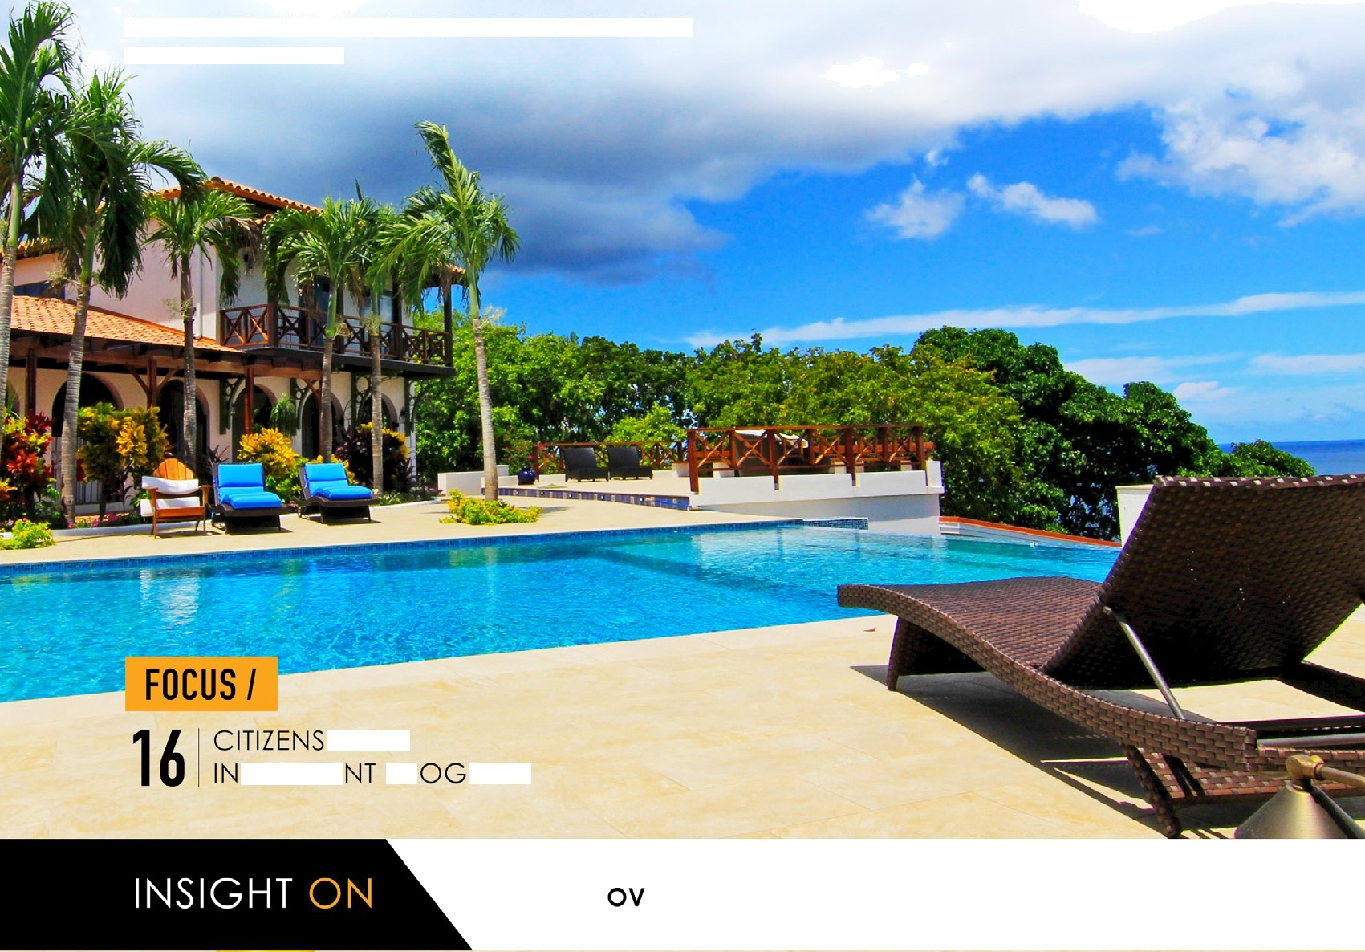CENTURY 2 - GRENADA GRENADINES REAL ESTATE
VALU AT IONS DIVISION

ERVIEW ASSESSMENT TRENDS

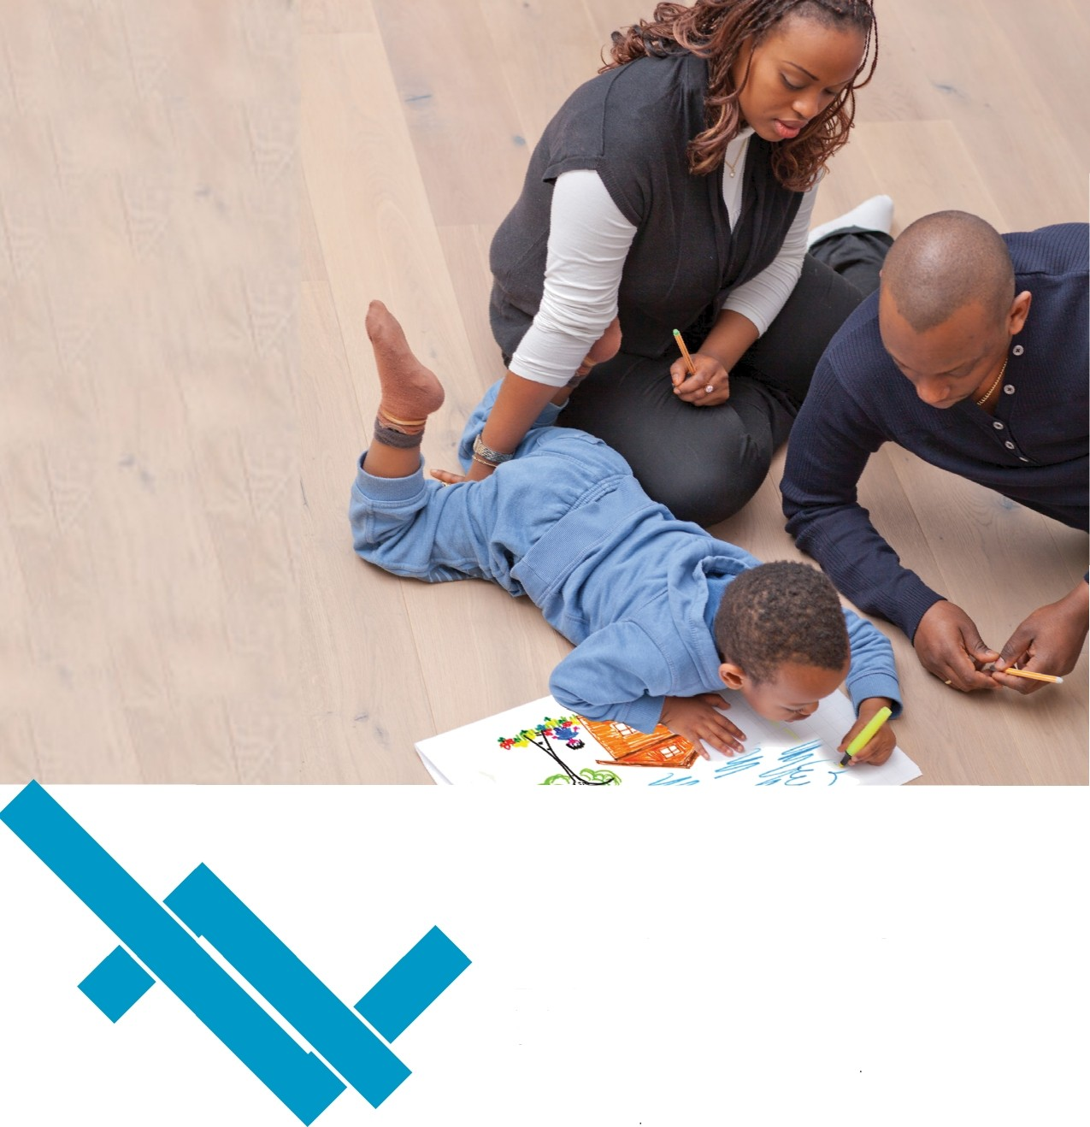The Bank Of The New
House On The Block (Yours)
There’s no place like... Let’s make Home happen.
Imagine moving into your very own home in as little as two weeks. Or building from scratch with a Bank that understands your vision and partners with you. Or even moving in before you pay your first installment. Republic Bank can help you make your dreams of home ownership come true

Visit us or log on to republicgrenada.com and check out our mortgage options. We'll get you home

info‹érepubIicgrenada.com
Republic
Bank

republicgrenada.com
We’re the One for you!

Thank you for using www.freepdfconvert.com service!

Only two pages are converted. Please Sign Up to convert all pages. https://www.freepdfconvert.com/membership

