Marine Pollution Survey
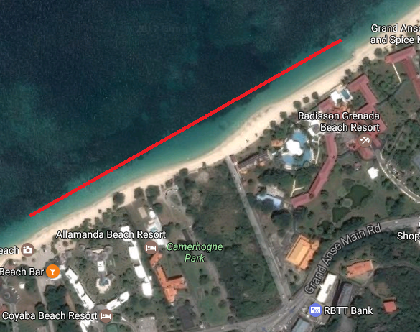
We carried out our surveys between the months of March 2016 to January 2017 at Grand Anse Beach in Grenada. A total of 96 people took part in the marine clean-ups. They collected a total of 955 lbs of garbage/debris as they either snorkelled or dived, depending on the particular date.

We carried out our dives/snorkels between the Radisson Hotel Drain to Eco-Dive, Coyaba Hotel. The general depth of water we dived or snorkelled in was between 1-5m deep. The maximum depth of the water was 2 meters deep and the visibility was OK. The substrate (ground below us) was usually Sand and the ecosystem (the environment we were diving in) was seagrass.
The dives and snorkels were usually carried out on sunny days. At the start of the survey period the seas were usually calm but towards the end of 2016 we had terrible storms e.g. Tropical Storm Matthew, which caused sea swells which pushed the waves almost up to the doors at Eco Dive - we think that maybe the waves pushed the sand over the garbage and covered it which is why we didn’t find as much debris towards the end of the survey period.
The top five items we collected were:
- Plastic bottles 584
- Plastic food containers 397
- Plastic food wrappers 395
- Metal Drinks Cans 276
- plastic bags 270
Luckily we never found any entangled animals. We took photos record what we found.

In total we collected 955lbs of debris. That is the same as the average weight of 12 Grade 6 children. Of that total 75% of the debris was plastic (2164 items) and 13% (376 items) were metal materials.

Looking at the total number of items over time we can see there is a large increase and then a drop in the amount of garbage we collected between August and November 2016. This is around the same time that people arrive in Grenada for Carnival and then leave. Even so it is clear that there is a regular amount of garbage in the sea whether we have special events or not.

Over three quarters of all the items found were food-related items (food or drink), some of which include plastic bottles, food wrappers, food containers and drinks cans. This shows that we are not disposing of our waste properly.

This graph shows that even before Carnival the amount of debris from food or drink items was increasing showing that we really need to do something to change people’s littering when visiting the beach or when disposing of their food items.

For some of our dives/snorkels we took part in the Adopt A Reef dives hosted by Eco-Dive. To show that this does not affect the amount of debris collected we divided the total weight of debris by t the total number of people taking part to get an average. As can be seen here it does not matter how many people take part as we seem to be able to find over 9 lbs of debris each time we search.
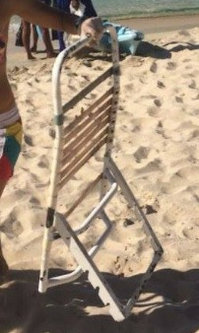
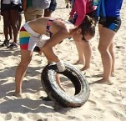
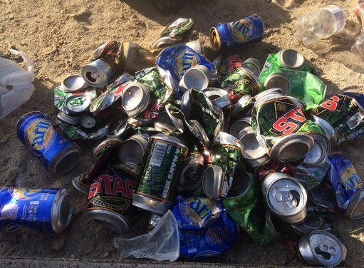
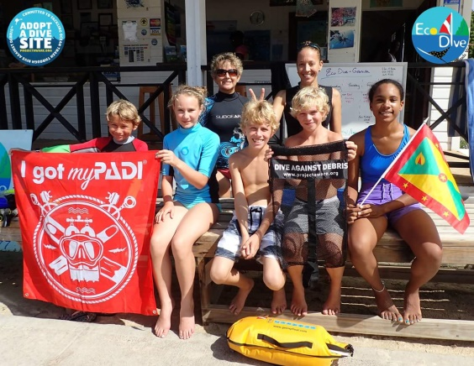
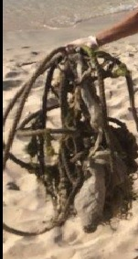

We collected 2164 plastic items in total over the year. We collected 1146 plastic items in September which is probably because of Carnival and visitors not disposing of their garbage properly.
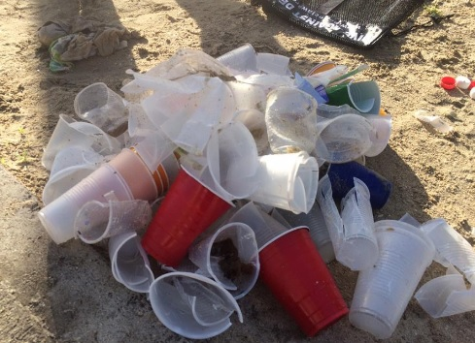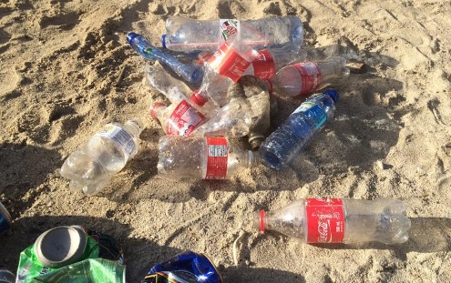

Plastic bottles (584 items, 27% of all plastic debris collected) were the most abundant of all the plastic materials we collected. The second most collected items were food containers (397 items, 18% of all plastic debris) followed by food wrappers (395 items, 18% of all plastic debris) and plastic bags (270 items, 12% of all plastic debris collected).

We collected 376 metal items in total over the year. We collected more items in July and September which may be due to summer holidays and Carnival.

We found 276 drinks cans (73% of all metal debris collected). The second most collected items were caps and lids (72 items, 19% of all plastic debris collected).

We collected 120 mixed debris items (4% of all debris collected) over the year. This did seem to be getting less and less as the year passed by though.

Of all the items in the Mixed Debris category, we found the most clothing (70 items, 58% of all mixed debris collected). The second most collected items were footwear (33 items, 28% of all mixed debris). We are not sure why there would be so many pieces of clothing or footwear in the sea unless perhaps it was all lost during the sailing regatta? We also collected toys and cell phones. The most horrible items collected were sanitary napkins which can seriously affect our health.

We collected 99 glass items in total over the year. This was 3% of all debris collected. Although the graph shows decreases and increases, on average it seems that there is a regular amount of glass dropped into the sea each throughout the year.

We found 69 glass bottles, 19 cups and dishes, 2 food jars and 9 pieces of glass.

We collected 70 cloth items in total over the year. This is 2% of all debris collected. Although the graph shows small decreases and increases, in general there seems to be cloth debris in our sea throughout the year with a bit more leading up to and during Carnival time.

We found 41 cloth fragments, 22 towels/rags, 5 bags and 2 pieces of rope.

We only found small amounts of rubber (20 pieces, 1% of all debris) with most being found in July when we found a lot of fragments.

We found 9 rubber fragments, 5 rubber bands, 3 tyres and 1 inner tube. The most horrible items were 2 condoms which are not only gross but are very unhealthy.

We only found small amounts of wood (17 pieces, 1% of all debris) with most being found in June when we found a lot of fragments.

We found 15 wood fragments and 2 pieces of lumber.

We only found small amounts Paper/Cardboard (13 pieces, 0.5% of all debris). This is probably because paper breaks down and dissolves very well.

We found 7 pieces of paper and 6 pieces of cardboard packaging.
Survey Number | 1 | 2 | 3 | 4 | 5 | 6 | 7 |  | Total
 | March | June | July | August | September | November | 01/01/2017
Location | Grand Anse Beach | Grand Anse Beach | Grand Anse Beach | Grand Anse Beach | Grand Anse Beach | Grand Anse Beach | Grand Anse Beach
Number of Participants | 22 | 8 | 7 | 9 | 40 | 5 | 5 |  | 96
Total Debris Collected | 210 | 75 | 85 | 82 | 500 | 2 | 1 |  | 955
Survey Duration (minutes) | 75 | 50 | 72 | 65 | 90 | 45 | 45 |  | 442
debris weight per person (average) | 9.55 | 9.38 | 12.14 | 9.11 | 12.50 | 0.40 | 0.20 |  | 53.27
Weather | Scattered shower, sunny | Sunny | sunny | sunny | sunny | sunny | sunny
Water | Calm -waves 0-0.1m high | Calm -waves 0-0.1m high | Calm -waves 0-0.1m high | Calm -waves 0-0.1m high | Calm -waves 0-0.1m high | Smooth - waves 0.1-0.5m high | Slight - waves 0.5-1.25m high
Depth | 0-5m | 0-5m | 0-5m | 0-5m | 0-5m | 0-5m | 0-5m
Dominant substrate | seagrass | Sand | Sand | Sand | seagrass | seagrass | seagrass
Ecosystem | seagrass | sand/seagrass | Seagrass | seagrass | seagrass | seagrass | seagrass
Total Items | 389 | 354 | 398 | 351 | 1343 | 9 | 35 |  | 2879
PLASTIC MATERIALS | 236 | 264 | 232 | 246 | 1146 | 7 | 33 |  | 2164 | 75%
GLASS & CERAMIC MATERIALS | 30 | 21 | 21 | 0 | 27 | 0 | 0 |  | 99 | 3%
METAL MATERIALS | 46 | 39 | 105 | 68 | 115 | 2 | 1 |  | 376 | 13%
RUBBER MATERIALS | 3 | 3 | 12 | 0 | 2 | 0 | 0 |  | 20 | 1%
WOOD MATERIALS | 2 | 7 | 5 | 0 | 3 | 0 | 0 |  | 17 | 1%
CLOTH MATERIALS | 16 | 4 | 6 | 18 | 26 | 0 | 0 |  | 70 | 2%
PAPER/CARBOARD MATERIALS | 7 | 1 | 0 | 4 | 0 | 0 | 1 |  | 13 | 0%
MIXED MATERIALS | 49 | 15 | 17 | 15 | 24 | 0 | 0 |  | 120 | 4%
Food & Drink Associated Items | 230 | 286 | 313 | 291 | 1238 | 5 | 29 |  | 2392 | 83%
Other | 159 | 68 | 85 | 60 | 105 | 4 | 6 |  | 487 | 17%
PLASTIC MATERIALS | 236 | 264 | 232 | 246 | 1146 | 7 | 33 |  | 2164 | 75%
Bags: grocery/retail/trash (plastic) | 56 | 16 | 64 | 73 | 51 | 4 | 6 |  | 270 | 12%
Bait containers/packaging | 5 | 0 | 2 |  |  |  |  |  | 7 | 0%
Balloons, Balls | 3 | 1 |  | 3 | 2 |  |  |  | 9 | 0%
beverage bottles | 26 | 83 | 62 | 43 | 368 |  | 2 |  | 584 | 27%
bottles: bleach cleaner, oil etc. |  | 1 | 1 |  |  |  |  |  | 2 | 0%
buckets drums and jerry cans: 2ltrs or more |  | 0 |  | 2 | 1 |  |  |  | 3 | 0%
caps & lids (plastic) | 25 | 27 | 43 | 5 | 41 |  | 2 |  | 143 | 7%
cigarette filters | 8 | 5 |  |  |  |  |  |  | 13 | 1%
cigarette lighters | 2 | 1 |  |  |  |  |  |  | 3 | 0%
cigar tips | 4 | 0 |  |  |  |  |  |  | 4 | 0%
containers: fast food, lunchboxes & similar | 17 | 32 | 25 | 6 | 312 |  | 5 |  | 397 | 18%
cups, plates forks knives, spoons (plastic) | 16 | 19 |  | 37 | 21 | 1 | 5 |  | 99 | 5%
diapers/nappies | 3 | 2 | 6 |  |  |  |  |  | 11 | 1%
fishing: line | 7 | 6 |  | 8 | 3 | 1 |  |  | 25 | 1%
fishing: lures rods/poles | 2 |  |  |  |  |  |  |  | 2 | 0%
fishing: nets/pieces of nets | 1 | 1 |  |  |  |  |  |  | 2 | 0%
foam insulation and packaging | 8 | 2 |  |  |  |  |  |  | 10 | 0%
food wrappers (plastic) | 21 | 43 |  | 41 | 287 |  | 3 |  | 395 | 18%
furnishings (plastic) |  |  |  |  | 1 |  |  |  | 1 | 0%
pipes (plastics/PVC) | 2 |  |  |  |  |  |  |  | 2 | 0%
rope (plastic/nylon) | 3 |  |  | 1 |  |  |  |  | 4 | 0%
scuba and snorkel gear (masks, snorkels, fins) | 9 | 2 | 6 |  |  |  |  |  | 17 | 1%
sheeting: tarpaulin, plastic sheets, palette wrap | 1 |  | 1 |  |  |  |  |  | 2 | 0%
6-pack rings, ring carriers | 1 |  |  |  | 1 |  |  |  | 2 | 0%
strapping bands (plastic) |  |  | 4 |  |  |  |  |  | 4 | 0%
straws, stirrers, cotton bud sticks | 6 | 11 |  | 18 | 15 |  | 5 |  | 55 | 3%
tampon applicators | 1 |  |  |  |  |  |  |  | 1 | 0%
tobacco packaging & wrappers | 2 |  |  |  |  |  |  |  | 2 | 0%
toothbrushes | 1 |  | 1 |  |  |  |  |  | 2 | 0%
plastic fragments | 6 | 12 | 17 | 9 | 43 | 1 | 5 |  | 93 | 4%
GLASS & CERAMIC MATERIALS | 30 | 21 | 21 | 0 | 27 | 0 | 0 |  | 99 | 3%
beverage bottles (glass) | 19 | 21 | 14 |  | 15 |  |  |  | 69 | 70%
cups, plates, tableware, dishes (glass & ceramic) |  |  | 7 |  | 12 |  |  |  | 19 | 19%
jars: food (glass) | 2 |  |  |  |  |  |  |  | 2 | 2%
glass and ceramic fragments | 9 |  |  |  |  |  |  |  | 9 | 9%
METAL MATERIALS | 46 | 39 | 105 | 68 | 115 | 2 | 1 |  | 376 | 13%
Aerosol/spray cans |  | 1 |  |  |  |  |  |  | 1 | 0%
batteries: AA/AAA etc. | 5 | 4 |  |  |  |  |  |  | 9 | 2%
beverage cans (aluminum) | 32 | 22 | 56 | 55 | 111 |  |  |  | 276 | 73%
caps & lids (metal) |  | 12 | 42 | 13 | 4 |  | 1 |  | 72 | 19%
cars &car parts |  |  | 3 |  |  |  |  |  | 3 | 1%
fishing: sinkers, lures, hooks |  |  |  |  |  | 2 |  |  | 2 | 1%
forks, knives, spoons, (cutlery) | 9 |  |  |  |  |  |  |  | 9 | 2%
wire mesh, barbed wire |  |  | 4 |  |  |  |  |  | 4 | 1%
RUBBER MATERIALS | 3 | 3 | 12 | 0 | 2 | 0 | 0 |  | 20 | 1%
Condoms |  |  |  |  | 2 |  |  |  | 2 | 10%
inner tube & rubber sheets |  | 1 |  |  |  |  |  |  | 1 | 5%
rubber bands |  | 2 | 3 |  |  |  |  |  | 5 | 25%
tires | 3 |  |  |  |  |  |  |  | 3 | 15%
rubber fragments |  |  | 9 |  |  |  |  |  | 9 | 45%
WOOD MATERIALS | 2 | 7 | 5 | 0 | 3 | 0 | 0 |  | 17 | 1%
lumber (processed or cut/milled wood) | 2 |  |  |  |  |  |  |  | 2 | 12%
wood fragments |  | 7 | 5 |  | 3 |  |  |  | 15 | 88%
CLOTH MATERIALS | 16 | 4 | 6 | 18 | 26 | 0 | 0 |  | 70 | 2%
bags (cloth) | 3 |  |  |  | 2 |  |  |  | 5 | 7%
rope and string (cloth) |  |  | 2 |  |  |  |  |  | 2 | 3%
towels, rags | 13 |  | 1 |  | 8 |  |  |  | 22 | 31%
cloth fragments |  | 4 | 3 | 18 | 16 |  |  |  | 41 | 59%
PAPER/CARBOARD MATERIALS | 7 | 1 | 0 | 4 | 0 | 0 | 1 |  | 13 | 0%
cardboard, packaging & cartons |  | 1 |  | 4 |  |  | 1 |  | 6 | 46%
paper, books, newspapers, magazines etc. | 7 |  |  |  |  |  |  |  | 7 | 54%
MIXED MATERIALS | 49 | 15 | 17 | 15 | 24 | 0 | 0 |  | 120 | 4%
Clothing | 28 | 13 | 7 | 6 | 16 |  |  |  | 70 | 58%
computer equipment & electronic devices | 4 |  |  |  | 1 |  |  |  | 5 | 4%
shoes, flip-flops, sandals, tennis etc. | 14 |  | 8 | 7 | 4 |  |  |  | 33 | 28%
toys | 3 |  | 2 | 2 |  |  |  |  | 7 | 6%
roof shingles |  | 2 |  |  |  |  |  |  | 2 | 2%
sanitary napkins |  |  |  |  | 3 |  |  |  | 3 | 3%
Contributing Factors |  |  | Carnival | Carnival |  | storm surge | storm surge
Most problematic items | plastic bags, tin cans, clothing | food containers, food wrappers, plastic bottles | plastic bags, plastic bottles, drinks cans | plastic bottles, plastic food containers, plastic | plastic bottles, plastic food containers, plastic food wrappers | plastic bags, fishing items | plastic bags, plastic containers, cutlery, plastic fragments

