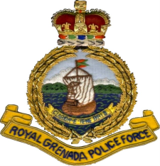
19The offence was
Public Relations Section
Community Relations Department
Royal Grenada Police Force
Police Headquarters
Fort George
ST. GEORGE’S

Ref. No. …………….
In replying the above
Number and date of this
Letter should be quoted.

PRESS RELEASE

Breakthrough in Unsolved Homicide

Two St. Mark residents have been arrested and charged in the 2012 murder of Amelio Nelson, 78 years, of Non-Pariel (St. Mark) who was found dead on November 30th 2012.

Charged in his death are Jamel Young, alias ‘Uncle’, 34 years Fisherman of Non-Pariel (St. Mark) and Ronald Fletcher, 36 years, Farmer of Munich, St. Andrew who previously resided at Non-Pariel.

Both men will appear at the Victoria Magistrate’s Court on Tuesday 16th June, 2020 jointly charged with Capital Murder, Arson, Burglary, Robbery with Violence and Causing Damage by Setting Fire. The offenses were alleged to have occurred between November 29th and 30th 2012.
Additional charges of Illegal Possession of Firearm and Ammunition have also been laid against Ronald Fletcher.

Source: Office of Commissioner of Police

Contact: Community Relations Department
440-3764; 405-5324

Date: Sunday 14th June, 2020
Tele: 440-3764 440-3999
Email: crd@rgpf.gd;

