# National Ozone Unit (NOU), Energy Division in the Ministry of Finance, Economic Development and Energy

# In Conjunction with

# The Global Project “Cool Contribution Fighting Climate Change” (C4)

# New Call for Tender for a Suitable Demonstration Site for the Application of

# Solar-Powered Green Air Conditioning in Grenada

July 2021

Application Deadline: 31st of July 2021

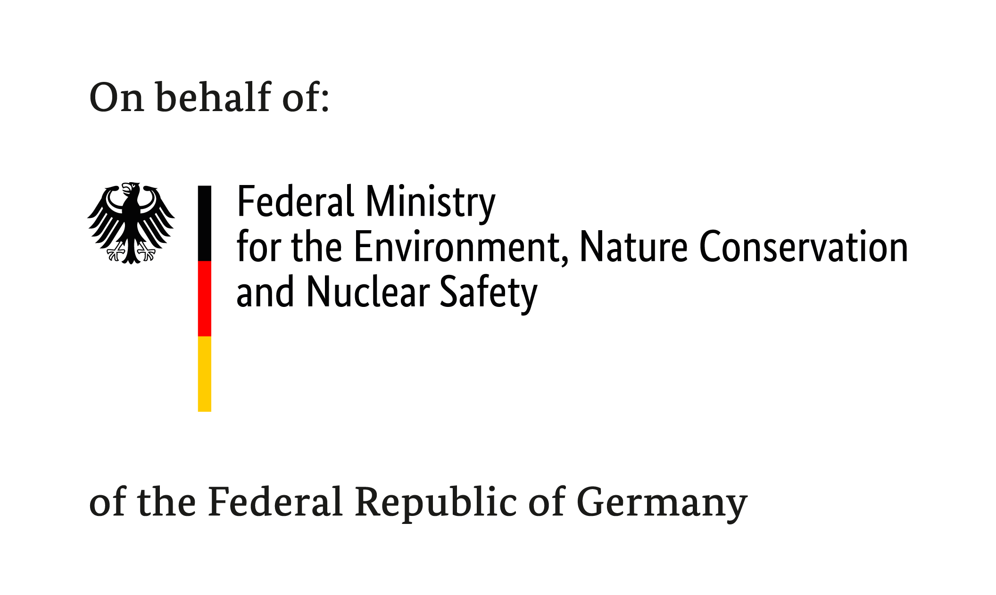

## Cool Contributions Fighting Climate Change

Cool Contributions fighting Climate Change (C4) is a project commissioned by the German Federal Ministry for the Environment, Nature Conservation and Nuclear Safety (BMU) and implemented by Deutsche Gesellschaft für Internationale Zusammenarbeit (GIZ).

C4 supports partner countries, like Grenada, in the development of Greenhouse gas (GHG) mitigation strategies in the field of refrigeration and air conditioning (RAC). These strategies are to be integrated into the countries' national climate goals, the nationally determined contributions (NDCs).

## Call for Proposals: Solar-Powered Green Air Conditioning in Grenada

C4 aims to demonstrate solar-powered Green Air Conditioning in cooperation with a private partner in Grenada.

Apply with your concept and seek for technical advice and financial support to realize Green Air Conditioning powered by a photovoltaic (PV) system in your premises.

The cooperation foresees the following contributions in a joint project to be realized in 2021:

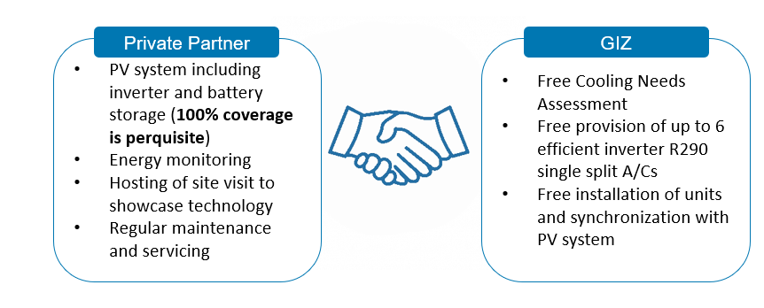

## General Information on the Call for Proposals

|  |  |
| --- | --- |
| **Implementing organisation** | Cool Contributions Fighting Climate Change (C4)  c/o Deutsche Gesellschaft für Internationale  Zusammenarbeit (GIZ) GmbH  Ministerial Complex, Botanical Gardens  P.O. Box 3269, St. George’s  Grenada, W.I.  Internet: <https://www.giz.de/en/worldwide/69156.html> |
| **Application deadline** | 31st of May 2021 |
| **Submit application by e-mail to** | [GD_Inquiry@giz.de](mailto:GD_Inquiry@giz.de) |

# Become our partner!

Private sector entities shall be eligible to participate if:

1. Adequate space requiring cooling is available
2. Solid ceilings (concrete, drop or tiled) and walls
3. The entity works with technicians trained in flammable refrigerant technology (hydrocarbons)
4. The room meets the minimum area and installation height for the charge size of the efficient inverter split ACs with 12000 BTU and / or 18000 BTU cooling capacity:
   * For the 12 000 BTU unit[1] the room size shall be at least 17m2 (with minimum installation height of 1.8 m)
   * For the 18 000 BTU unit[2] the room size shall be at least 23m2 (with minimum installation height of 1.8 m)
5. The following should be considered for the indoor unit:

* There shall be no electric appliance, power switch or socket under the indoor unit.
* There should be a minimum distance of about 1 m from TV-sets or any other electrical appliances.
* The air inlet and outlet vent should not be obstructed, make sure that the air can be blown throughout the entire room

1. Ready to actively participate in the promotion of climate-friendly green cooling:

* Providing information and access to the equipment for public awareness and promotional purposes
* Make available for the general public information
* Participate during outreach events and stakeholder consultations
* Provide a mechanism for data collection, monitoring and servicing of the equipment throughout the appliance’s lifetime.

1. 100% PV powered AC is guaranteed:

The installed ACs should be supplied with 100% PV energy. The applicant shall provide evidence of current electricity consumption of the building (kwh/year) and

1. Rated output of the installed PV system (kWh/year)
2. proof of the planned installation of a PV system, including information on the rated output (kWh/year);

**or**

1. proof of secured financing for a PV system and planned capacity/ rated output (kWh/year)

Private sector entities shall **not** be eligible to participate if:

1. The presence of strong heat sources, combustible gases, vapors or volatiles substances are present in the room
2. The environment possesses high frequency waves, e.g. by radio equipment, medical or welding equipment
3. Places with very contaminated air (such as places with oil containing air)

## Application

C4 invites eligible private sector candidates to submit their Expressions of Interest by answering the questions outlined in the application form (A) and by completing the technical questionnaire (B):

1. **Application Form**

Data of the company

|  |  |
| --- | --- |
| **Name of company** |  |
| **Address** |  |
| **Website (if applicable)** |  |
| **Contact (name, phone number, e-mail address, position)** |  |
| **Legal status** |  |
| **Year of foundation** |  |
| **Commercial register no.** |  |

**Short description of the company (max. 20 lines)**

* Short company profile
* What experience does your company have in the green cooling/renewable energy sector? Please list references of past projects and specify which green cooling/renewable energy technology your company has specialised (i.e. which natural refrigerant, which energy source and which cooling subsector).

**Short description of your concept (no more than 1 page)**

* What is the substantial objective of your concept?
* Which specific measures and activities are to achieve this objective?
* What management and monitoring activities are planned?
* Which staff resources do you intend to use for installation, maintenance and other activities related to renewable energy-powered green cooling?
* Outline briefly your long-term business interest and explain how you ensure sustainability once cooperation draws to a close.

**Short description of potential for outreach and awareness (no more than 1/2 page)**

* Demonstrate your willingness to participate in outreach and awareness campaigns
* Explain how you intent to promote Solar-Powered Green Air Conditioning in Grenada and which means for awareness raising and PR you have available

1. **Technical Questionnaire**

Please fill in the following questionnaire as comprehensive and accurate as possible. It will help us assess whether your proposed project site fulfils the technical requirements.

1. What is the height and size of the rooms in need for air conditioning? Please specify:

|  |  |  |  |  |
| --- | --- | --- | --- | --- |
|  | Room 1 | Room 2 | Room 3 | Room 4 |
| Room height  (in ft or m, please specify) |  |  |  |  |
| Room size  (in sq ft or m2, please specify) |  |  |  |  |

1. Can a minimum distance of about 1m between the ACs and any other electrical appliances be ensured?
2. Are there any windows in the rooms for air conditioning? If yes, please state number of windows per room in need for air conditioning.

|  |  |  |  |  |
| --- | --- | --- | --- | --- |
|  | Room 1 | Room 2 | Room 3 | Room 4 |
| Number of windows |  |  |  |  |

1. Does the room have solid ceilings (concrete, drop, or tiled) and walls?
2. Can an unobstructed air flow through the room be guaranteed?
3. Is the air in the room contaminated (e.g. oil containing air)?
4. Are there any high-frequency waves present in the environment? (This includes waves emitted by radio equipment, medical equipment, or welding equipment.)
5. Are there any strong heat sources, combustible gases, vapors or volatiles substances present in the room?
6. Are there any electric appliances, power switches, or sockets/plugs in 1m radius to the envisaged location of the indoor unit of the split Air Conditioner? If yes, please provide details.
7. Have you ever acquired split air conditioners installed by qualified service AC technicians before?
8. What is the rated power of the installed/planned PV system (kWh/year)?
9. What is the current electricity consumption of the building (kWh/year)? (please attach the electricity consumption of 3 months as a reference)

**Following the assessment of submissions, a Memorandums of Understanding (MOU) will be established between the NOU, C4 Project, the private sector entity. The project reserves the right to accept or reject late applications or to cancel the present invitation partially or in its entirety. It will not be bound to assign any reason for not short‑listing any applicant and will not defray any costs incurred by any applicant in the preparation and submission of Expressions of Interest.**

**Notes on completing the application form:**

When completing the application form, please keep within the given space limits and follow the guide questions in your description.

Should you express your interest as part of a consortium/working group, we ask you to fill in the above data for each partner and nominate one lead agency.

Proposals are to be submitted in English.

Interested applicants can consult with the Cool Contributions Fighting Climate Change (C4) project before submitting the application. For this purpose, please contact [GD_Inquiry@giz.de](mailto:GD_Inquiry@giz.de).

There is no legal entitlement to be selected as a partner of this project.

C4 will not reimburse any costs incurred by the company in connection with participating in the Call for Proposals or drafting the concept.

**Acknowledgments**

We affirm that the above information is complete and correct.

X__________________________________________________________

Date and Signature

**Optional data**

The following question is optional. However, we would appreciate your feedback to optimize our communication.

How did you get into touch with Cool Contributions Fighting Climate Change?

____________________________________________________________

1.
2.